Hands-on 4: Spring Core – Load Country from Spring Configuration XML

Project Explorer
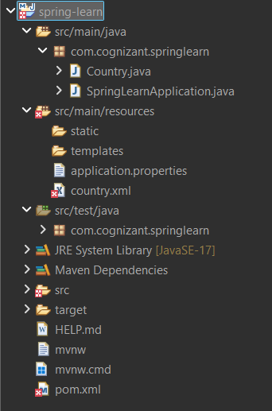

Country.java
package com.cognizant.springlearn;
public class Country {
private String code;
private String name;
public Country() {
System.out.println("Inside Country Constructor");
}
public String getCode() {
System.out.println("Inside getCode()");
return code;
}
public void setCode(String code) {
System.out.println("Inside setCode()");
this.code = code;
}
public String getName() {
System.out.println("Inside getName()");
return name;
}
public void setName(String name) {
System.out.println("Inside setName()");
this.name = name;
}
@Override
public String toString() {
return "Country [code=" + code + ", name=" + name + "]";
}
}

country.xml
<?xml version="1.0" encoding="UTF-8"?>
<beans xmlns="http://www.springframework.org/schema/beans"
xmlns:xsi="http://www.w3.org/2001/XMLSchema-instance"
xsi:schemaLocation="http://www.springframework.org/schema/beans https://www.springframework.org/schema/beans/spring-beans.xsd">
<bean id="country" class="com.cognizant.springlearn.Country">
<property name="code" value="IN"/>
<property name="name" value="India"/>
</bean>
</beans>

SpringLearnApplication.java
public static void displayCountry() {
ApplicationContext context =
new ClassPathXmlApplicationContext("country.xml");
Country country = context.getBean("country", Country.class);
System.out.println(country);
((ClassPathXmlApplicationContext)context).close();
}
public static void main(String[] args) {
SpringApplication.run(SpringLearnApplication.class, args);
displayCountry();
}

Console Output

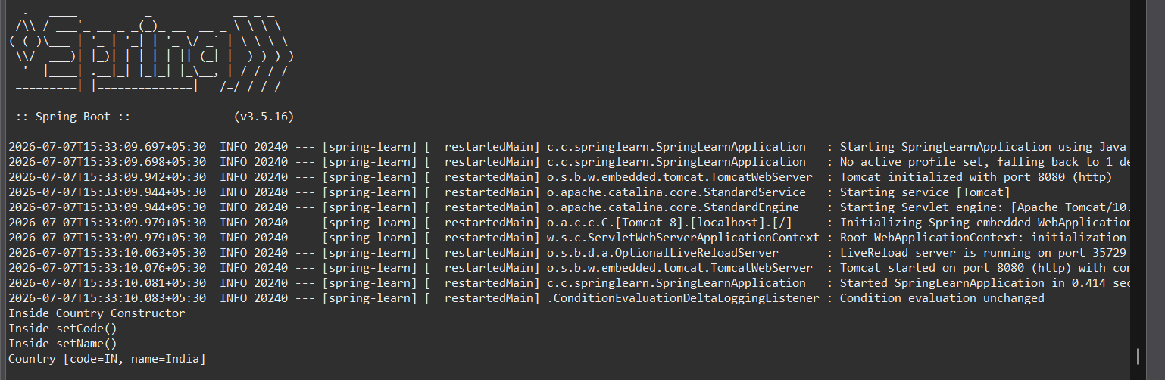

Conclusion
The Country bean was successfully loaded from the Spring XML configuration file and its details were displayed using Spring Core.

